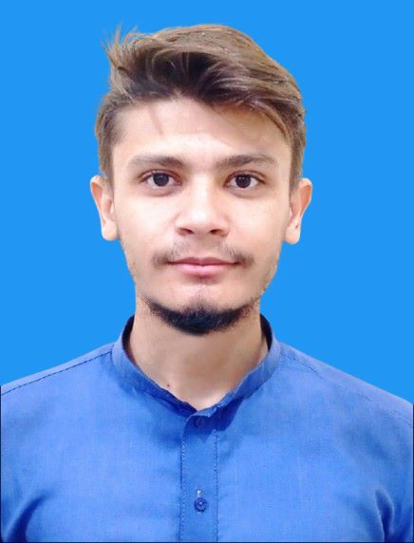**Muhammad Hammad**

# Python Programmer

**Phone :** 0313 0993701 / 03331028010

**Email :** hm746765@gmail.com

**LinkedIn :**linkedin.com/-hammad-yousafzai

**GitHub** **:** github.com/Mafia-Deadend

**Languages :** English, Urdu , Pushto

# Professional Summary

Dedicated Python Programmer and Multimedia Specialist with expertise in AI-based projects, Database, and application development. Proficient in building AI systems, computer vision applications. Passionate about using programming and design to innovate and solve real-world problems, with strong skills in Python.

# Education

## Bachelor of Science in Computer Science

University Of Peshawar | 2020 - 2024

**Technical Skills**

**Programming**:

* Python
* Flutter
* Dart
* Kotlin

**Python Libraries & Frameworks**:

**AI and Machine Learning**:

OpenCV, TensorFlow, YOLO, PyTorch, Whisper, Hugging Face, Librosa, Transformers, ONNX, Google Cloud Text-to-speech, Kaggle.

**Database in** SQL Alchemy,

## Automation in Pyautogui , User Interface in Tkinter,

**Encryption and decryption** in Pycryptodomex, Cryptograhy,

**Data Science** in Numpy, Pandas, Matplotlib,

- **Web Development**: HTML, CSS, CSS, Bootstrap, **Python** : Flask, DJANGO

**Additional Skills :**

## Ai Websites and tools Knowledge Mobile Application Development : Flutter + Dart Language

**Graphic Design & Video Editing**: Adobe Photoshop, Premiere Pro, After Effects, Wondershare Filmora, Canva

**Technical Projects**

## AI-Based Quran Recitation Recognition

- Developed a research-backed project using Python for voice recognition of Quranic recitations, incorporating AI and machine learning algorithms.

## Computer Vision Projects

* **Face Detection & Gesture Control**: Implemented face detection using OpenCV’s Haar cascades.
* **Object Detection**: Used YOLO for real-time crowd detection from CCTV using DMSS and OBS Studio.
* **Workshops Presented**: Conducted workshops on CNN, GNN, and OpenCV fundamentals, including crowd and object detection techniques.

## Data Analysis

* Conducted cryptographic performance analysis, comparing encryption and decryption methods through data visualization with Matplotlib, Numpy, and Pandas.

## Automation and Mini Projects

* **PyGUI Automation**: Developed automation workflows and created games like Tic Tac Toe and Lucky Guess.

## Flutter Projects

## Quran Recitation & Memorization App

* Developed an offline Quran app in Flutter with real-time TFLite-based voice recognition, enabling madrasa students to practice recitation without internet. Features include a 'Hifz' mode that hides text, revealing verses as recited to support memorization.

## Islamic Calendar & Masnoon Duas App

* Created an Islamic utility app that provides a Hijri calendar with custom colour themes and a collection of Masnoon duas.
* Integrated UI components to ensure ease of navigation and accessibility, enhancing the user experience.

**Notes Taking App**

* Designed a straightforward notes-taking app with functionality for organizing and categorizing notes.
* Employed a clean UI for efficient note management, allowing users to quickly add, edit, and delete entries.

**Calculator App**

* Built a user-friendly calculator app with essential arithmetic operations and a visually appealing layout.
* Focused on responsive design to ensure compatibility across different screen sizes.